On problems quantum computers can solve efficiently
Vu Tuan Hai¹
¹University of Information Technology, Ho Chi Minh City, 700000, Vietnam;
²Vietnam National University, Ho Chi Minh City, 700000, Vietnam.
Received ; Revised ; Accepted ; Published.
DOI: https://doi.org/10.54939/1859-1043.j.mst.101.2025.13-22
ABSTRACT
Quantum computers exploit quantum mechanics to process information in ways that are fundamentally different from classical computers. While quantum computers are not expected to replace classical systems for general-purpose computing, they can efficiently solve specific classes of computational problems that are intractable for conventional machines. This paper reviews the major categories of problems should be considered for implementing on the quantum computer. The theoretical foundations of quantum complexity are introduced, followed by an analysis of representative algorithms such as quantum walks. The source of quantum advantages are discussed, also the bottleneck of popular models such as quantum machine learning.
Keywords: quantum computing, quantum machine learning, complexity theory, quantum advantage
1. INTRODUCTION
The increasing complexity of science and engineering has exposed fundamental limitations of classical computing systems. Although advances in semiconductor technology have significantly improved computational performance over recent decades, many NP problems, including cryptanalysis [1], molecular simulation [2], and large-scale optimization [3], remain intractable due to their exponential growth in complexity. Consequently, researchers have increasingly explored alternative computational paradigms capable of addressing problems that are beyond the practical reach of conventional computers.
Quantum computing has emerged as one of the most promising approaches for overcoming these limitations. Recent advances in quantum hardware have accelerated progress on scalable platforms, and nearby reviews highlight significant improvements in qubit fidelity, error mitigation techniques, and hardware scalability, demonstrating steady progress toward useful quantum computation [4, 5]. The primary motivation for quantum computing stems from the existence of quantum algorithms that outperform the best-known classical algorithms [6].
In recent years, quantum computing has attracted substantial attention from academia, industry, and government agencies (NQI, Quantum Information Science Megaproject, Quantum Technologies Flagship, ...), resulting in a rapid increase in the number of proposed quantum algorithms and application-specific models. However, despite this growing body of research, many proposed quantum approaches remain largely theoretical and have not yet demonstrated consistent and reproducible advantages on practical real-world tasks. Furthermore, recent studies indicate that quantum advantage remains limited [7]. Consequently, before developing new quantum algorithms or applying quantum techniques to existing problems, it is essential to identify computational tasks for which a plausible quantum advantage exists and to select algorithms supported by rigorous theoretical and empirical analysis. Identifying an appropriate problem -algorithm pairing is therefore a prerequisite for the realistic assessment of its future impact [8].

2. THEORETICAL FOUNDATIONS
2.1. Quantum complexity
The primary motivation for quantum computing originates from computational complexity theory, which studies the resources required to solve computational problems. Let $T(N)$ denote the computational time required to solve a problem of size $N$. A problem is generally considered tractable if $T(N)=O(N^{k})$ for some small constant $k$, and intractable if $T(N)=O(c^{N}) (c>1)$ or $T(N)=O(N!)$ where computational time grows exponentially with $N$. The complexity class $P$ contains all decision problems solvable by a deterministic Turing machine within polynomial time (efficiently solvable). Examples include graph traversal, shortest path algorithms, and primality testing. The class $NP$ consists of decision problems whose solutions can be verified in polynomial time. Equivalently, for a language ($L∈NP$), there exists a polynomial-time verifier ($V$) such that
$$\begin{matrix}x∈L⇔∃y, |y|=\text{poly}(|x|), V(x,y)=1.\end{matrix} (1)$$
Quantum computers introduce new computational models and corresponding complexity classes, $EQP,BQP$, and $ZQP$. Exact Quantum Polynomial Time ($EQP$) contains problems solvable by a quantum computer in polynomial time with perfect probability $P(\text{correct answer})=1$. Although theoretically important, $EQP$ excludes many practical quantum algorithms because quantum measurements are inherently probabilistic. Zero-error Quantum Polynomial Time ($ZQP$) allows a quantum algorithm to return either a correct answer or an inconclusive result $P(\text{incorrect answer})=0$. The most important class in quantum computing is Bounded-error Quantum Polynomial Time ($BQP$), which contains problems solvable by a quantum computer in polynomial time with bounded error probability. The language $L$ belongs to $BQP$ if there exists a quantum algorithm such that $P(\text{correct answer})≥\frac{2}{3}$ for for YES instances and $≤1/3$ for NO instances with $T(N)=O(N^{k})$. The constant ($2/3>1/2$) is arbitrary because repeated execution can amplify the success probability:
$$\begin{matrix}P^{(t)}(\text{failure})≤{\left(1/3\right)}^{t}.\end{matrix} (2)$$
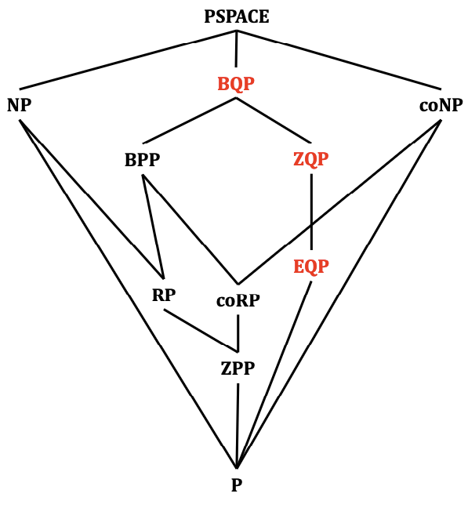
Figure 1. Relationship between complexity classes: dividing by classical, probabilistic, and quantum Turing machines (highlighted). $BPP$: Bounded-error Probabilistic Polynomial Time, $ZPP$: Zero-error Probabilistic Polynomial Time. $RP$: Random Turing Machine in Polynomial time with false negative only, $\text{co}RP$: Random Turing Machine in Polynomial time with false positive only, $ZPP=RP∩\text{co}RP$. Clearly, $EQP⊆ZQP⊆BQP$. While the exact relationship between $BQP$, $NP$, and $\text{co}NP$ remains unknown.
2.2. Fast search algorithm
Suppose a database contains $N$ unsorted entries and exactly one satisfies a target condition. A classical exhaustive search requires $T_{C}(N)≈O(N)$ queries on average. Grover’s algorithm reduces this complexity to $T_{Q}(N)≈O(\sqrt{N})$ [9]. The quadratic speedup arises from amplitude amplification. After approximately $R≈\frac{π}{4}\sqrt{N}$ iterations, the probability of measuring the target state approaches unity:
$$\begin{matrix}P(\text{success})=\sin^{2}\left((2R+1)θ\right), θ=\sin^{-1}(\frac{1}{\sqrt{N}})\end{matrix} (3)$$
Although a quadratic speedup is less dramatic than the exponential advantage of Shor’s algorithm, Grover’s method applies to a much broader range of problems. Any task reducible to unstructured search, including password cracking, key search, pattern matching, database lookup, and certain optimization procedures, can potentially benefit from Grover - style acceleration. Consequently, symmetric cryptographic systems typically require doubling key lengths to maintain equivalent security against quantum adversaries. Because the derivation of Grover’s algorithm is beyond the scope of this article, we instead illustrate quantum speedup using a quantum walk in Example 1.
Example 1. Take the random variable $z∈\{-1,1\}$. The series $\{S_{n}\}$ is a 1-D random walk with $S_{0}=0$ and $S_{n}=\sum_{i=1}^{n}{z_{i}}$, following a normal distribution, where a quantum walk makes the walker in the superposition:
$$\begin{matrix}|↑⟩⊗|0⟩\overset{H}{→}\frac{1}{\sqrt{2}}\left((|↑⟩+|↓⟩)⊗|0⟩\right)\overset{S}{→}\frac{1}{\sqrt{2}}\left((|↑⟩|0⟩+|↓⟩⊗|1⟩\right)\end{matrix} (4)$$
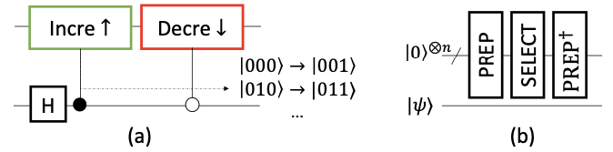
Figure 2. (a) Quantum walk is described as the product of two unitary operators: coin flip operator $C$ and shift operator $S$. (b) Quantum circuit for block-encoding algorithm.
Assume that we have a complete graph $P_{j}$ with $N$ nodes, and $P_{j^{*}}$ is the target node. One approach is using a random walker. Note that the walker must be somewhere, i.e., $∑P_{j}=1 ∀j$. At step 0, we jump to other random nodes $P_{j}=1/N$. When done with step 1: $P_{j^{*}}=1/N+1/(N(N-1))×(N-1)=2/N$ because $P_{j^{*}}$ acts as an absorbing node and so on for step $t$. $P_{C}^{(t)}(\text{success})=1-\frac{N-1}{N}(\frac{N-2}{N-1})^{t}$ with a corresponding runtime $O(N)$.
Assuming we change classical walk to quantum walk with initial wave function $|ψ^{(0)}⟩=[α_{00} α_{01} …]^{⊺}$. At step $k$, we apply the query oracle $Q$, coin flip $C$, and shift operator (walk) $S$ interactively, $(SCQ)^{k}|ψ^{(0)}⟩$.
$$\begin{aligned}&P_{Q}^{(t)}(\text{success})=\frac{{\left\{(N-1)[cos(ϕt)+\sqrt{2N-3}sin(ϕt)]+(-1)^{t}(N-2)\right\}}^{2}}{(2N-3)^{2}N}, \\ &ϕ=\sin^{-1}(\sqrt{2N-3}/(N-1)), (5)\end{aligned}$$
with a corresponding runtime $O(\sqrt{N})$.
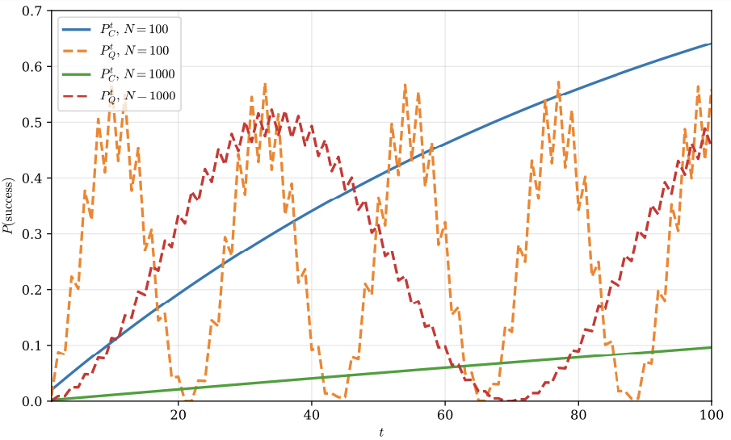
Figure 3. $P(\text{success})$ versus $N$ by classical walker $(C)$ and quantum walker $(Q)$. The $P_{Q}^{(t)}(\text{success}) (N=100)$ achieves high probability from very first iterations.
2.3. Data preparation
A fundamental challenge arises from the fact that, in some cases, classical data must first be converted into quantum states. Given a classical vector $x$, many quantum algorithms assume access to the amplitude-encoded state
$$\begin{matrix}|x⟩=\frac{1}{|x|}\sum_{i=0}^{N-1}{x_{i}}|i⟩\end{matrix} (6)$$
subsequent quantum operations may require only $O(logN)$ qubits. In the absence of specialized hardware such as Quantum Random Access Memory (QRAM), the preparation cost can scale as Eq. 9, which may eliminate any theoretical speedup. This issue becomes particularly important in algorithms that rely on block encodings. Given a matrix $A$, many modern quantum algorithms assume the existence of a unitary operator $U_{A}$ satisfying
$$\begin{matrix}U_{A}=\left[\begin{matrix}A/α & * \\ * & *\end{matrix}\right]\end{matrix} (7)$$
where $α≥|A|$. Such a representation allows quantum singular value transformation (QSVT) [10] and Hamiltonian simulation techniques to operate efficiently [11]. However, constructing the block encoding is often non-trivial. If the matrix is dense and provided classically, generating ($U_{A}$) may require preprocessing costs proportional to $O(N^{2})$
$$\begin{matrix}⟨0|{\text{PREP}}^{†}⋅\text{SEL}⋅\text{PREP}|0⟩=A/λ|ψ⟩\end{matrix} (8)$$
where λ=k​|αk|, A=k​αkUk is the linear of combination unitary (LCU) of $A$.
3. QUANTUM ADVANTAGE
The practical value of quantum computing does not arise from accelerating every computational task. Rather, quantum advantage [6] emerges when a problem exhibits a mathematical structure that can be exploited through quantum interference and entanglement. A meaningful quantum advantage exists when $\lim_{N→∞}T_{C}(N)/T_{Q}(N)→∞$. Shor’s algorithm achieves exponential advantage for factorization, while Grover’s algorithm achieves quadratic advantage for unstructured search. These algorithms remain the most compelling demonstrations that quantum computers can solve certain practically relevant problems more efficiently than classical computers, providing the theoretical foundation for ongoing research in quantum algorithms, quantum cryptography, and quantum information processing.
3.1. The importance of Heuristics in quantum algorithms
Theoretical analyses of quantum algorithms typically focus on the complexity of the quantum computation itself while assuming the existence of suitable input states, block encodings, or oracle constructions. However, practical performance often depends more strongly on the ability to exploit problem-specific structure through heuristics. The overall computational time can be expressed as
$$\begin{matrix}T_{prep}×T_{refine}(N,ϵ),T_{\text{prep}}≈O(poly(N)), (9)\end{matrix}$$
where $T_{prep}$ denotes the time of preparing a useful representation of the problem and $T_{refine}(L,ϵ)$ denotes the time of finding the solution within accuracy $ϵ$. Quantum algorithms frequently provide provable improvements in the refinement stage, reducing the asymptotic dependence on $N$ or $ϵ$. However, these advantages may be overshadowed if $T_{prep}≫T_{refine}$. This observation is particularly relevant in quantum simulation and quantum machine learning. Many quantum algorithms assume the availability of a high-quality initial state that has substantial overlap with the target solution. Constructing such states often requires domain knowledge. In practice, the success of the algorithm may depend less on the formal quantum speedup and more on the quality of these heuristic assumptions [12].
A common approach is to identify problems that are believed to be classically intractable and then demonstrate that a quantum algorithm can solve them more efficiently. However, this perspective may not accurately reflect practical computational workloads. Classical algorithms achieve remarkable performance by exploiting problem-specific structure, physical intuition, and heuristic approximations. Consequently, the effective complexity observed in practice is often substantially lower than worst-case theoretical bounds. Recent work has argued that quantum advantage should not be evaluated solely against worst-case classical algorithms, but rather against the best classical methods operating under realistic heuristic assumptions [13]. Heuristics significantly reduce $T_{prep}$, allowing classical methods to solve instances that would otherwise appear computationally prohibitive. As a result, searching for quantum advantage exclusively in regions where classical heuristics fail may identify problems that are mathematically interesting but have limited practical relevance. An alternative viewpoint is to ask whether quantum algorithms can achieve speedups even when the same heuristic information is available. Under this perspective, the objective is not to compete against an idealized worst-case classical algorithm but against the strongest available classical workflow. If a quantum algorithm can exploit domain knowledge, physical structure, or learned representations while still reducing computational complexity, then the resulting advantage is more likely to be relevant in real-world applications.
The implication is that the central research question shifts from Can quantum computers solve classically intractable problems? to Can quantum computers provide meaningful speedups under the same heuristic assumptions available to classical methods?. Answering this question may provide a more realistic path toward practical quantum advantage than focusing exclusively on worst-case complexity separations.
3.2. Source of quantum advantages
Practical quantum advantage may also arise from sufficiently large polynomial improvements. In many scientific applications, particularly quantum chemistry and many-body physics, the computational challenge originates from the dimensionality of the underlying state space rather than from an inherently hard combinatorial problem.
3.2.1. Many-body simulation
Consider a system consisting of $m$ particles, each having $N$ possible states. The corresponding Hilbert space has dimension $D=N^{m}$. A classical algorithm operating directly on the state vector must store $O(N^{m})$ complex amplitudes. Common linear algebra operations such as matrix–vector multiplication $U|ψ⟩$ require computational time scaling as $O(N^{m+c})$. Quantum computers, in contrast, represent the same Hilbert space using only $m\log_{2}N$ qubits. Hamiltonian simulation can manipulate operators acting on the full $N^{m}$-dimensional space without explicitly storing all amplitudes [11]. Under suitable assumptions regarding sparsity and efficient block-encoding constructions, the computational cost may scale as $poly(m)×poly(N)$ while the storage requirement becomes $O(mlogN)$. The quantum state itself is the object of interest, eliminating the need to repeatedly encode large classical datasets into quantum memory. Consequently, the exponential growth of the Hilbert space becomes a resource that quantum hardware can naturally exploit rather than a bottleneck.

3.2.2. Locality
In systems with geometric locality, the computational complexity of classical sparse linear algebra methods for solving the eigenvalue problem $\hat{H}c=Ec$ is governed not only by the sparsity of the Hamiltonian $\hat{H}$ but also by the growth of correlation volume in the effective $m$ - quasi-particle configuration space. Starting from a sparse initial state, repeated applications of a local Hamiltonian generate a light-cone structure whose support expands with the correlation length $L_{c}∼nR_{c}$, where $n$ is the number of iterations and $R_{c}$ denotes the interaction range. Consequently, the number of nonzero amplitudes that must be tracked classically scales as the correlation volume of the quasiparticle manifold $N_{corr}∼(nR_{c})^{mD}=L_{c}^{mD}$ where $D$ is the physical dimension of the system. The resulting classical computational time can therefore be expressed as $T_{C}∼nsL_{c}^{mD}$ with $s$ denoting the sparsity of $\hat{H}$. In contrast, quantum algorithms based on QSVT apply an $n^{\text{th}}$-order polynomial of the Hamiltonian without explicitly storing or propagating the light-cone data. Assuming an efficient block encoding of $\hat{H}$, the quantum complexity scales as $T_{Q}∼nsT_{\text{BE}}$. The resulting quantum advantage is approximately
$$\begin{matrix}\frac{T_{C}}{T_{Q}}∼\frac{L_{c}^{mD}}{T_{BE}},\end{matrix} (10)$$
demonstrating that significant speedups can emerge whenever the classical correlation volume grows substantially faster than the block-encoding overhead. This perspective identifies locality-induced light-cone growth as a fundamental source of quantum advantage for many-body simulation and sparse linear-algebra problems.
4. LIMITATIONS OF QUANTUM MACHINE LEARNING
Quantum machine learning (QML) has become one of the most actively studied topics [14, 15], with numerous works claiming potential computational advantages over classical machine learning techniques [16]. Several studies have pointed out that the performance gains reported by many QML models are often based on small-scale experiments, idealized simulations, or assumptions that may not hold on current noisy quantum hardware. Several recent studies have argued that many purported speedups rely on assumptions that neglect the cost of data preparation [13, 17-19]. Consequently, the total runtime becomes
$$\begin{matrix}T_{\text{total}}=T_{\text{load}}+T_{\text{BE}}+T_{\text{Q}}, T_{\text{load}}+T_{\text{BE}}≫T_{\text{Q}} (11)\end{matrix}$$
causes the data preparation stage to dominate overall execution time. In extreme cases, constructing the block encoding may require more computational effort than solving the original problem using optimized classical algorithms. This observation explains why many theoretically attractive QML algorithms have not yet demonstrated practical superiority over classical machine learning systems. While quantum subroutines may exhibit asymptotic complexities such as $O(logN)$ or $O(polylog(N))$, these results frequently assume idealized access models that hide the cost of data acquisition and encoding. This suggests that many current QML proposals may not provide practical advantages for large classical datasets.
5. WHICH PROBLEMS QUANTUM COMPUTERS SOLVE EFFICIENTLY?
The existence of a quantum speedup must be evaluated using an end-to-end complexity analysis rather than considering only the quantum portion of the computation. Interestingly, the same phenomenon has long been observed in classical computing. Modern classical simulation methods, machine learning systems, and optimization algorithms achieve remarkable performance not solely through favorable asymptotic complexity but also because they effectively exploit structure present in real-world data. Therefore, comparisons between classical and quantum algorithms should not focus exclusively on worst-case complexity bounds. Instead, a fair assessment must account for the cost of obtaining useful representations.
Recent studies have therefore suggested that some of the most compelling near-term opportunities for quantum advantage may arise in quantum simulation [20], condensed matter physics, and quantum chemistry [21, 22]. In these domains, the objective is not necessarily to achieve exponential asymptotic speedups, but rather to obtain large polynomial improvements for physically relevant system sizes. Since practical applications often involve systems with $m≈6-8$ interacting quasi-particles or more, even a reduction from $O(N^{m+c})$ to $poly(m)poly(N)$ may translate into substantial computational savings. For many QML proposals, the bottleneck is not the quantum circuit itself but the process of converting classical information into a form suitable for quantum processing.
6. CONCLUSIONS
As a result, identifying problems with naturally quantum inputs, structured sparse matrices, efficiently constructible block encodings, or intrinsically quantum data may be more important than developing models. Just as classical AI benefits from learning informative representations of data, future quantum algorithms may require mechanisms for learning problem structure before any theoretical quantum advantage can be realized. Consequently, future quantum advantage may emerge not from avoiding classical heuristics but from combining them with uniquely quantum computational primitives. Despite rapid progress, important challenges remain. Current quantum computers operate in the Noisy Intermediate-Scale Quantum (NISQ) era, where limited qubit counts, decoherence, and hardware noise restrict the execution of large-scale, fault-tolerant algorithms [23]. Recent assessments indicate that substantial advances in error correction are still required before quantum computers can consistently outperform classical supercomputers on commercially relevant tasks [24].
Acknowledgement: This work was inspired by discussions at the Quantum Advantage for Computational Chemistry workshop, Simons Institute for the Theory of Computing, May 29, 2026. V.T.H. is partially supported by the VNUHCM - University of Information Technology’s Scientific Research Support Fund.
REFERENCES
[1] Shor, P.W.: Algorithms for quantum computation: discrete logarithms and factoring. SFCS ’94, pp. 124–134. IEEE Computer Society, USA (1994). https://doi.org/10.1109/SFCS.1994.365700
[2] Peruzzo, A., McClean, J., Shadbolt, P., Yung, M.-H., Zhou, X.-Q., Love, P.J., Aspuru-Guzik, A., O’Brien, J.L.: A variational eigenvalue solver on a photonic quantum processor. Nature Communications 5(1), 4213 (2014) https://doi.org/10.1038/ncomms5213
[3] Farhi, E., Goldstone, J., Gutmann, S.: A Quantum Approximate Optimization Algorithm (2014)
[4] Carrera Vazquez, A., Tornow, C., Rist`e, D., Woerner, S., Takita, M., Egger, D.J.: Combining quantum processors with real-time classical communication. Nature 636(8041), 75–79 (2024) https://doi.org/10.1038/s41586-024-08178-2
[5] Acharya, R., AI, G.Q., Collaborators: Quantum error correction below the sur- face code threshold. Nature 638(8052), 920–926 (2025) https://doi.org/10.1038/s41586-024-08449-y
[6] Arute, F., al.: Quantum supremacy using a programmable superconducting processor. Nature 574(7779), 505–510 (2019) https://doi.org/10.1038/s41586-019-1666-5
[7] Tuziemski, J., Pawlowski, J., Tarasiuk, P., Pawela, L., Gardas, B.: Limits of quantum run-time advantage. Phys. Rev. Appl. 25, 044084 (2026) https://doi.org/10.1103/gpsf-pn1x
[8] Eisert, J., Preskill, J.: Mind the gaps: The fraught road to quantum advantage (2026)
[9] Grover, L.K.: A fast quantum mechanical algorithm for database search. In: Proceedings of the Twenty-Eighth Annual ACM Symposium on Theory of Computing. STOC ’96, pp. 212–219. Association for Computing Machinery, New York, NY, USA (1996). https://doi.org/10.1145/237814.237866
[10] Gily´en, A., Su, Y., Low, G.H., Wiebe, N.: Quantum singular value transformation and beyond: exponential improvements for quantum matrix arithmetics. In: 10 Proceedings of the 51st Annual ACM SIGACT Symposium on Theory of Computing. STOC 2019, pp. 193–204. Association for Computing Machinery, New York, NY, USA (2019). https://doi.org/10.1145/3313276.3316366
[11] Low, G.H., Chuang, I.L.: Hamiltonian Simulation by Qubitization. Quantum 3, 163 (2019) https://doi.org/10.22331/q-2019-07-12-163
[12] Chan, G.K.-L.: Quantum chemistry, classical heuristics, and quantum advantage (2024)
[13] Huang, H.-Y., Kueng, R., Preskill, J.: Information-theoretic bounds on quantum advantage in machine learning. Phys. Rev. Lett. 126, 190505 (2021) https://doi.org/10.1103/PhysRevLett.126.190505
[14] Schuld, M., Killoran, N.: Quantum machine learning in feature hilbert spaces. Phys. Rev. Lett. 122, 040504 (2019) https://doi.org/10.1103/PhysRevLett.122.040504
[15] Carleo, G., Cirac, I., Cranmer, K., Daudet, L., Schuld, M., Tishby, N., Vogt-Maranto, L., Zdeborov´a, L.: Machine learning and the physical sciences. Rev. Mod. Phys. 91, 045002 (2019) https://doi.org/10.1103/RevModPhys.91.045002
[16] Tang, E.: A quantum-inspired classical algorithm for recommendation systems. In: Proceedings of the 51st Annual ACM SIGACT Symposium on Theory of Computing. STOC 2019, pp. 217–228. Association for Computing Machinery, New York, NY, USA (2019). https://doi.org/10.1145/3313276.3316310
[17] Aaronson, S.: Read the fine print. Nature Physics 11(4), 291–293 (2015) https://doi.org/10.1038/nphys3272
[18] Cerezo, M., Verdon, G., Huang, H.-Y., Cincio, L., Coles, P.J.: Challenges and opportunities in quantum machine learning. Nature Computational Science 2(9), 567–576 (2022) https://doi.org/10.1038/s43588-022-00311-3
[19] Aaronson, S., Childs, A.M., Farhi, E., Harrow, A.W., Sanders, B.C.: Future of quantum computing. Quantum Machine Intelligence 8(1), 3 (2026) https://doi.org/10.1007/s42484-026-00351-2
[20] Babbush, R., Wiebe, N., McClean, J., McClain, J., Neven, H., Chan, G.K.-L.: Low-depth quantum simulation of materials. Phys. Rev. X 8, 011044 (2018) https://doi.org/10.1103/PhysRevX.8.011044
[21] Leimkuhler, O., Whaley, K.B.: Exponential quantum speedups for near-term molecular electronic structure methods (2026)
[22] Robledo-Moreno, J., Motta, M., Haas, H., Javadi-Abhari, A., Jurcevic, P., Kirby, 11 W., Martiel, S., Sharma, K., Sharma, S., Shirakawa, T., Sitdikov, I., Sun, R.-Y., Sung, K.J., Takita, M., Tran, M.C., Yunoki, S., Mezzacapo, A.: Chemistry beyond the scale of exact diagonalization on a quantum-centric supercomputer. Science Advances 11(25), 9991 (2025) https://doi.org/10.1126/sciadv.adu9991
[23] Preskill, J.: Quantum Computing in the NISQ era and beyond. Quantum 2, 79 (2018) https://doi.org/10.22331/q-2018-08-06-79
[24] Chowdhury, S., Aadit, N.A., Grimaldi, A., Raimondo, E., Raut, A., Lott, P.A., Mentink, J.H., Rams, M.M., Ricci-Tersenghi, F., Chiappini, M., Theogarajan, L.S., Srimani, T., Finocchio, G., Mohseni, M., Camsari, K.Y.: Pushing the boundary of quantum advantage in hard combinatorial optimization with probabilistic computers. Nature Communications 16(1), 9193 (2025) https://doi.org/10.1038/ s41467-025-64235-y
TÓM TẮT
Về những vấn đề máy tính lượng tử có thể giải hiệu quả
Máy tính lượng tử khai thác cơ học lượng tử để xử lý thông tin theo những cách hoàn toàn khác biệt so với máy tính cổ điển. Mặc dù máy tính lượng tử sẽ không thay thế máy tính cổ điển trong mọi tác vụ tính toán, chúng có thể giải quyết hiệu quả các lớp vấn đề cụ thể mà máy tính cổ điển không thể giải quyết được. Bài báo này xem xét các loại vấn đề cần được xem xét để triển khai trên máy tính lượng tử. Nền tảng lý thuyết về độ phức tạp lượng tử được trình bày, tiếp theo là phân tích các thuật toán tiêu biểu như bước đi lượng tử. Nguồn gốc của ưu thế lượng tử sẽ được thảo luận, cũng như điểm nghẽn của các mô hình như học máy lượng tử.
Từ khoá: Tínhtoán lượng tử, học máy lượng tử, lý thuyết độ phức tạp, ưu thế lượng tử.

Note that at intermediate steps we cannot observe the system. Then we do not know whether the current node is the target node or not
Apply a quantum coin flip $-I+2A$ that inverts each amplitude about the average amplitude at its vertex
Walker at vertex $i$ pointing to vertex $j$ to hop to vertex $j$ and point back to vertex $i$, i.e., swap $α_{ij}$ with $α_{ji}$.

